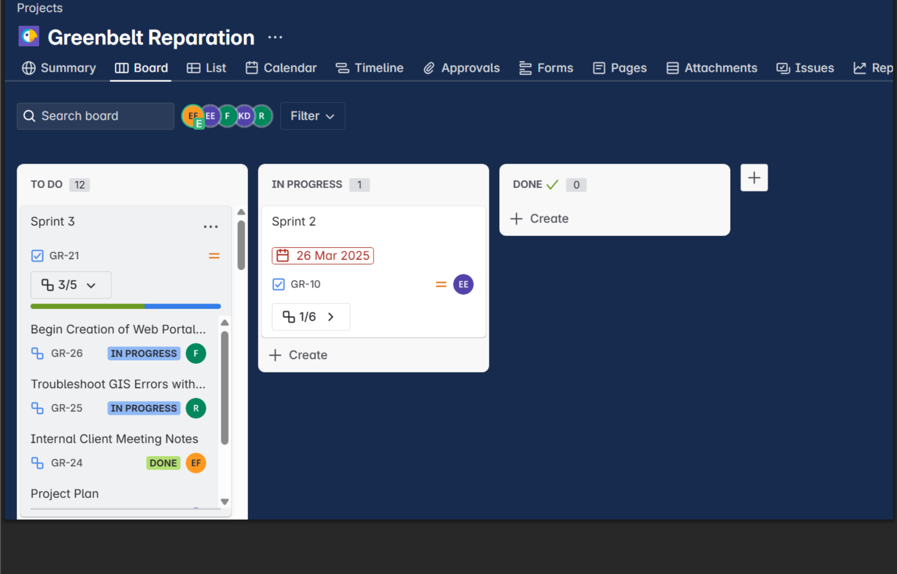

Couldn’t download the second screenshot team member submitted